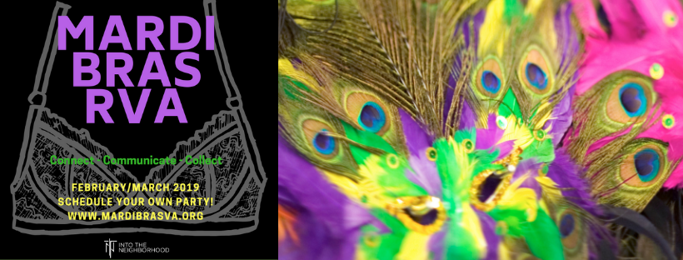

YOU ARE INVITED to a MARDI BRAS EVENT!

WHAT (Describe nature of your “collection” event…pot luck, wine & cheese, open house, etc.)
WHEN (Date & Time)
WHERE (Address)

WHAT IS MARDI BRAS ALL ABOUT?

How many pair of underwear do you have in your drawer right now? How many bras? When ‘that time of the month’ comes, do you wonder where you will obtain your supplies of pads or tampons? Sorry – if you are a guy and reading this, I dare you to ask your wife, daughter, sister, girlfriend, or mother these questions. Supplies are NOT readily available for women who are homeless or on a low or restricted income. Food stamps and other resources do not cover feminine protection. This is a problem that can be easily solved; and here’s how you can help do something about it.
MARDI GRAS, where women bare their breasts for beads in New Orleans, is right around the corner. Instead of revealing our breasts, we are going to work at covering some! Join us for MARDI BRAS VA!
WHAT WE ARE COLLECTING
- Menstrual Pads (Heavy flow, light days, etc. are all appreciated.)
- Tampons (All sizes are appreciated.)
- NEW Bras – of ALL sizes! Please remember larger sizes, too.
- NEW Women’s underwear – of ALL sizes! Please remember larger sizes, too.
- WHITE WIRELESS BRAS (like sports bras – all sizes!!! ) for the Richmond City Justice Center
In case you can’t make this event, we will be collecting items through (date) at (collection location).

For further information, look us up on Facebook:
Mardi Bras VA

Check out our link at
https://mardibrasva.org
https://intotheneighborhood.org

